**ShopBridge**

**Step 1 : Add New Product**

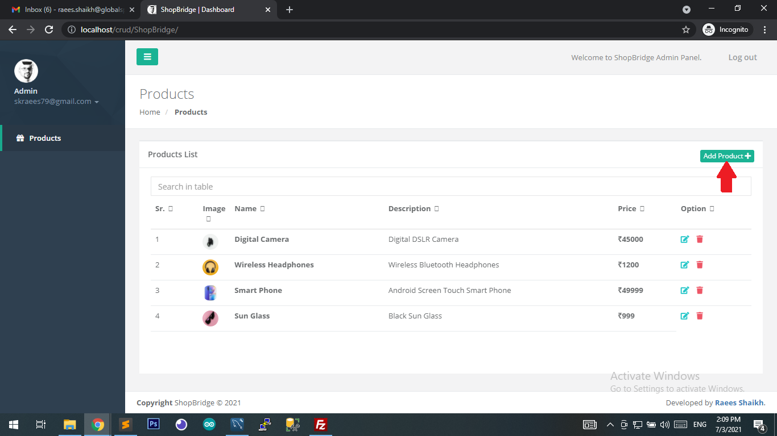

**Step 2 : Fill Details and Save**

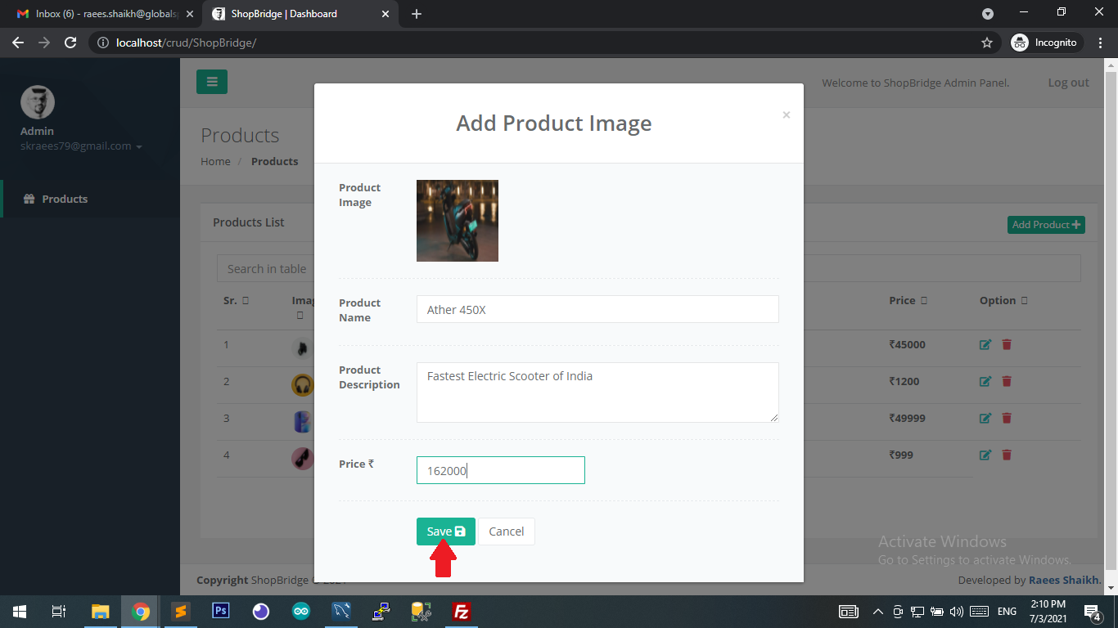

**Step 3 : Click Edit Product**

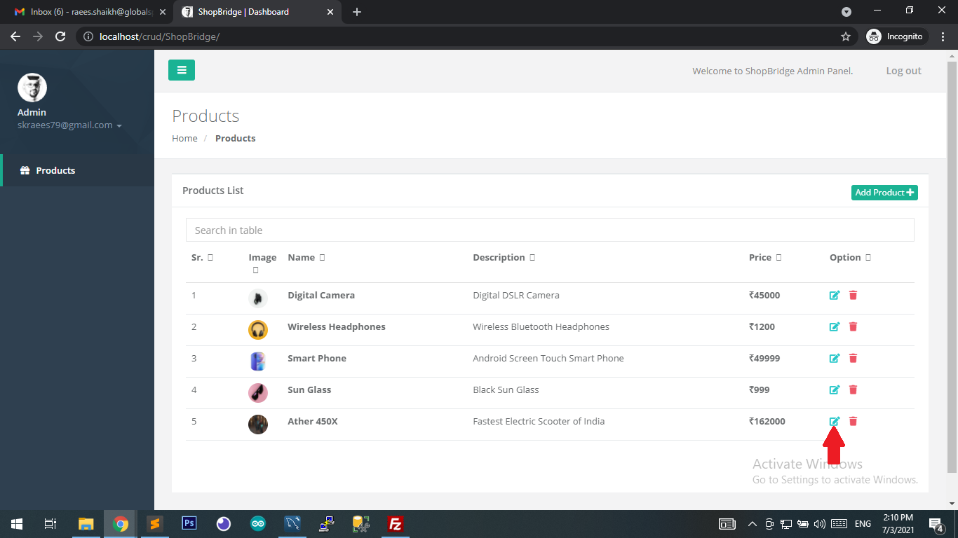

**Step 4 : Edit A Product Details and Save**

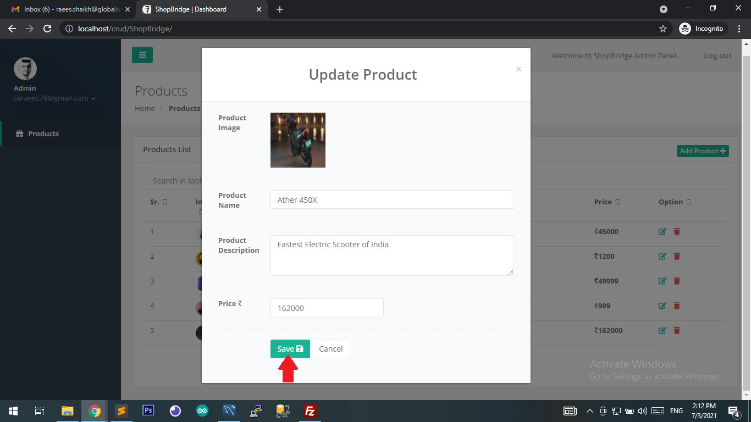

**Step 5 : Delete A Product**

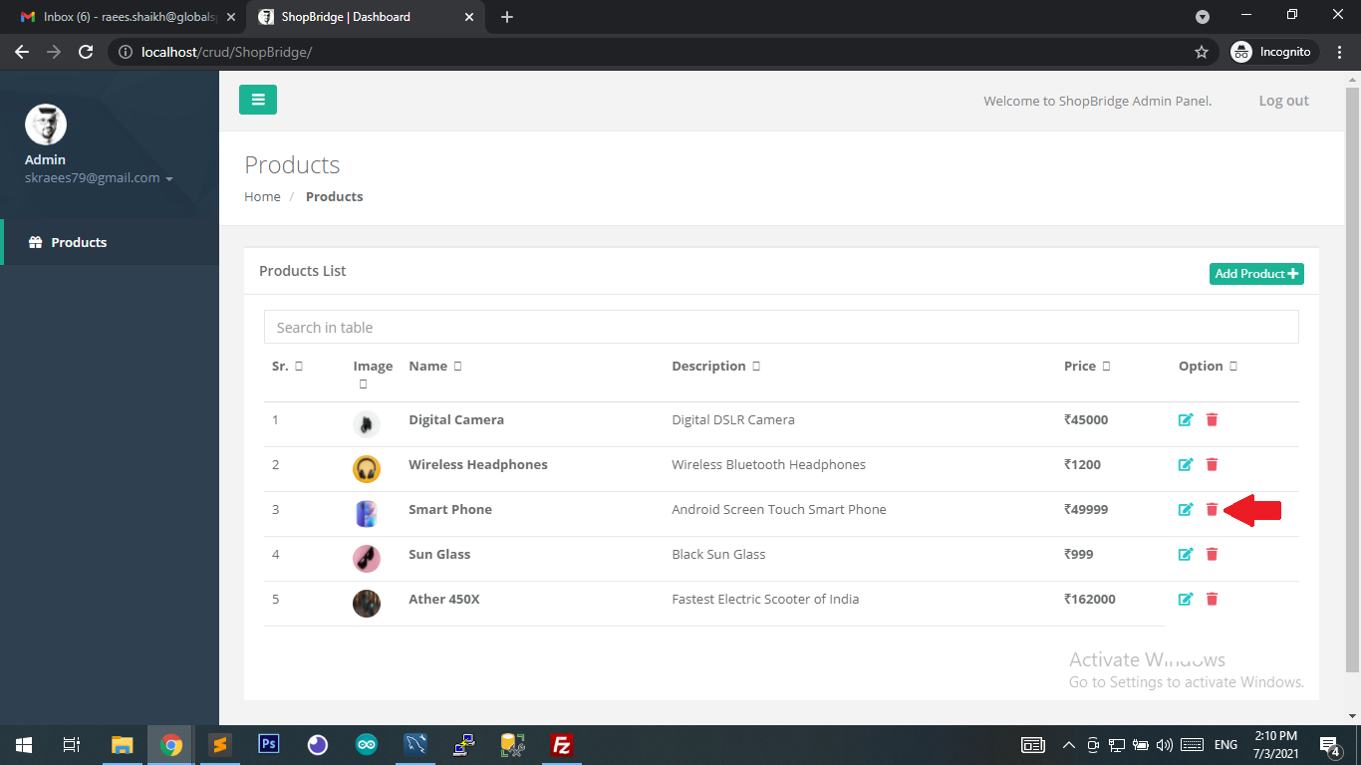

**Step 6 : Confirm Delete**

